Measurement Systems
# Source: AI Source: Provided by: [Data Path: Persons Table -> ID Column: 1, Name_En Column: Motasem Essam] -> From: [ChatGPT] on [7/17/2026]
A Measurement System is a standardized collection of units, rules, symbols, and conventions used to measure and express physical quantities such as length, mass, time, temperature, volume, and force.
Measurement systems ensure that measurements are consistent, accurate, and universally understood, allowing people in different places and disciplines to communicate and compare quantities effectively.

Definition
# Source: AI Source: Provided by: [Data Path: Persons Table -> ID Column: 1, Name_En Column: Motasem Essam] -> From: [ChatGPT] on [7/17/2026]
A Measurement System is an organized system of standard units and measurement rules used to quantify physical quantities.
A measurement is generally expressed as
$$\boxed{\text{Measurement}=\text{Numerical Value}×\text{Unit}}$$
where the unit belongs to a recognized measurement system.

Purpose of Measurement Systems
# Source: AI Source: Provided by: [Data Path: Persons Table -> ID Column: 1, Name_En Column: Motasem Essam] -> From: [ChatGPT] on [7/17/2026]
Measurement systems are designed to:
- Standardize measurements.
- Ensure consistency.
- Improve accuracy.
- Facilitate scientific research.
- Support engineering and manufacturing.
- Enable international trade.
- Simplify communication.
- Allow easy unit conversion.

Components of a Measurement System
# Source: AI Source: Provided by: [Data Path: Persons Table -> ID Column: 1, Name_En Column: Motasem Essam] -> From: [ChatGPT] on [7/17/2026]
A measurement system typically includes:
- Standard units
- Derived units
- Unit symbols
- Conversion rules
- Prefixes (where applicable)
- Measurement standards

Major Measurement Systems
# Source: AI Source: Provided by: [Data Path: Persons Table -> ID Column: 1, Name_En Column: Motasem Essam] -> From: [ChatGPT] on [7/17/2026]
The principal measurement systems used throughout history and today include:
- International System of Units (SI)
- Metric System
- CGS System
- MKS System
- FPS System
- Imperial System
- United States Customary System (USCS)

1. International System of Units (SI)
# Source: AI Source: Provided by: [Data Path: Persons Table -> ID Column: 1, Name_En Column: Motasem Essam] -> From: [ChatGPT] on [7/17/2026]
The International System of Units (SI) is the modern international standard for measurement.
It was officially adopted in 1960 by the General Conference on Weights and Measures (CGPM) and is based on the metric system.
Characteristics
- Decimal-based
- Uses powers of ten
- Internationally standardized
- Widely used in science, engineering, medicine, and commerce
SI Base Units
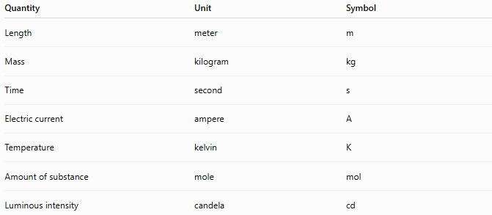
Quantity | Unit | Symbol
Length | meter | m
Mass | kilogram | kg
Time | second | s
Electric current | ampere | A
Temperature | kelvin | K
Amount of substance | mole | mol
Luminous intensity | candela | cd

2. Metric System
# Source: AI Source: Provided by: [Data Path: Persons Table -> ID Column: 1, Name_En Column: Motasem Essam] -> From: [ChatGPT] on [7/17/2026]
The Metric System is a decimal-based measurement system developed in France during the late 18th century.
It is the foundation of the SI system.
Characteristics
- Base 10
- Simple conversions
- Uses prefixes
Examples:
- millimeter
- centimeter
- meter
- kilometer
- gram
- kilogram
- liter

3. CGS System
# Source: AI Source: Provided by: [Data Path: Persons Table -> ID Column: 1, Name_En Column: Motasem Essam] -> From: [ChatGPT] on [7/17/2026]
The CGS (Centimeter–Gram–Second) System uses:
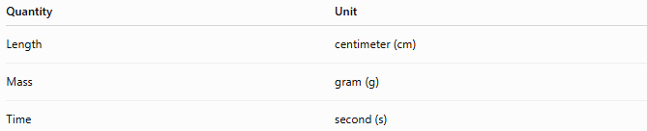
Quantity | Unit
Length | centimeter (cm)
Mass | gram (g)
Time | second (s)
Applications
- Classical physics
- Electromagnetism
- Older scientific literature

4. MKS System
# Source: AI Source: Provided by: [Data Path: Persons Table -> ID Column: 1, Name_En Column: Motasem Essam] -> From: [ChatGPT] on [7/17/2026]
The MKS (Meter–Kilogram–Second) System uses:
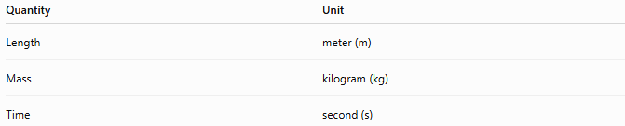
Quantity | Unit
Length | meter (m)
Mass | kilogram (kg)
Time | second (s)
The MKS system became the basis for the modern SI system.

5. FPS System
# Source: AI Source: Provided by: [Data Path: Persons Table -> ID Column: 1, Name_En Column: Motasem Essam] -> From: [ChatGPT] on [7/17/2026]
The FPS (Foot–Pound–Second) System uses:
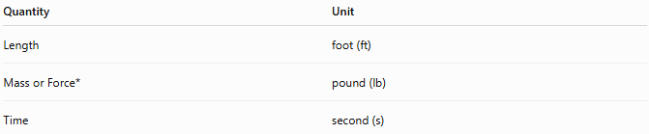
Quantity | Unit
Length | foot (ft)
Mass or Force* | pound (lb)
Time | second (s)
*Depending on the specific FPS variant, the pound may represent mass or force.
Applications
- Historical engineering
- Older mechanical systems

6. Imperial System
# Source: AI Source: Provided by: [Data Path: Persons Table -> ID Column: 1, Name_En Column: Motasem Essam] -> From: [ChatGPT] on [7/17/2026]
The Imperial System was developed in the United Kingdom in 1824.
Common Units
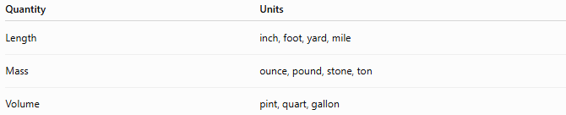
Quantity | Units
Length | inch, foot, yard, mile
Mass | ounce, pound, stone, ton
Volume | pint, quart, gallon
Applications
- United Kingdom (limited use)
- Historical engineering
- Aviation (some applications)

7. United States Customary System (USCS)
# Source: AI Source: Provided by: [Data Path: Persons Table -> ID Column: 1, Name_En Column: Motasem Essam] -> From: [ChatGPT] on [7/17/2026]
The United States Customary System evolved from older English units and is used primarily in the United States.
Common Units
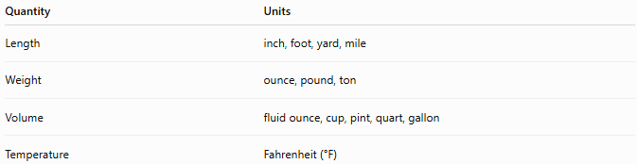
Quantity | Units
Length | inch, foot, yard, mile
Weight | ounce, pound, ton
Volume | fluid ounce, cup, pint, quart, gallon
Temperature | Fahrenheit (°F)

Comparison of Major Measurement Systems
# Source: AI Source: Provided by: [Data Path: Persons Table -> ID Column: 1, Name_En Column: Motasem Essam] -> From: [ChatGPT] on [7/17/2026]
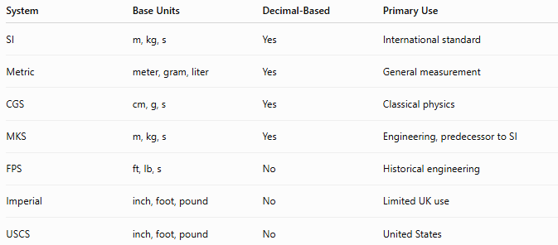
System | Base Units | Decimal-Based | Primary Use
SI | m, kg, s | Yes | International standard
Metric | meter, gram, liter | Yes | General measurement
CGS | cm, g, s | Yes | Classical physics
MKS | m, kg, s | Yes | Engineering, predecessor to SI
FPS | ft, lb, s | No | Historical engineering
Imperial | inch, foot, pound | No | Limited UK use
USCS | inch, foot, pound | No | United States

Advantages of Standard Measurement Systems
# Source: AI Source: Provided by: [Data Path: Persons Table -> ID Column: 1, Name_En Column: Motasem Essam] -> From: [ChatGPT] on [7/17/2026]
Standard measurement systems:
- Improve communication.
- Reduce measurement errors.
- Support scientific reproducibility.
- Simplify international trade.
- Facilitate engineering design.
- Allow accurate comparisons.
- Enable consistent manufacturing.

Applications
# Source: AI Source: Provided by: [Data Path: Persons Table -> ID Column: 1, Name_En Column: Motasem Essam] -> From: [ChatGPT] on [7/17/2026]
Measurement systems are used in:
- Mathematics
- Physics
- Chemistry
- Biology
- Engineering
- Construction
- Medicine
- Manufacturing
- Commerce
- Transportation
- Agriculture
- Astronomy

Everyday Examples
# Source: AI Source: Provided by: [Data Path: Persons Table -> ID Column: 1, Name_En Column: Motasem Essam] -> From: [ChatGPT] on [7/17/2026]
Measurement systems are used when:
- Measuring a person's height.
- Buying groceries by weight.
- Reading a thermometer.
- Filling a fuel tank.
- Measuring land area.
- Calculating travel distance.
- Designing buildings.
- Manufacturing machine parts.

Common Mistakes
# Source: AI Source: Provided by: [Data Path: Persons Table -> ID Column: 1, Name_En Column: Motasem Essam] -> From: [ChatGPT] on [7/17/2026]
- Mixing SI and Imperial units in calculations.
- Forgetting unit conversions.
- Confusing mass and weight.
- Using inappropriate units for a quantity.
- Omitting units from numerical values.

Key Points
# Source: AI Source: Provided by: [Data Path: Persons Table -> ID Column: 1, Name_En Column: Motasem Essam] -> From: [ChatGPT] on [7/17/2026]
- A measurement system is a standardized collection of units and rules.
- The SI System is the international standard.
- Most scientific work uses SI units.
- The Metric System forms the basis of SI.
- Imperial and US Customary systems are still used in some countries.
- Standard measurement systems ensure consistency, accuracy, and global communication.

SI System vs. Imperial System
# Source: AI Source: Provided by: [Data Path: Persons Table -> ID Column: 1, Name_En Column: Motasem Essam] -> From: [ChatGPT] on [7/17/2026]
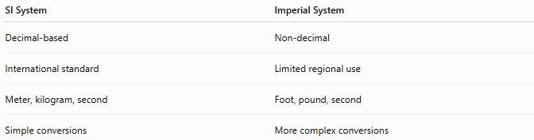
SI System | Imperial System
Decimal-based | Non-decimal
International standard | Limited regional use
Meter, kilogram, second | Foot, pound, second
Simple conversions | More complex conversions

Metric System vs. US Customary System
# Source: AI Source: Provided by: [Data Path: Persons Table -> ID Column: 1, Name_En Column: Motasem Essam] -> From: [ChatGPT] on [7/17/2026]
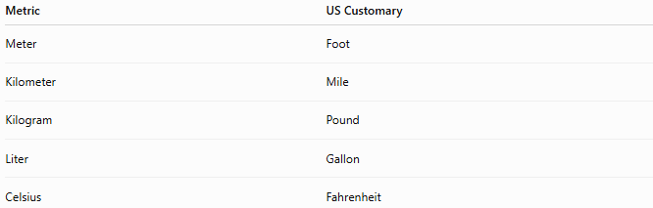
Metric | US Customary
Meter | Foot
Kilometer | Mile
Kilogram | Pound
Liter | Gallon
Celsius | Fahrenheit

Conclusion
# Source: AI Source: Provided by: [Data Path: Persons Table -> ID Column: 1, Name_En Column: Motasem Essam] -> From: [ChatGPT] on [7/17/2026]
A Measurement System is a standardized framework of units, symbols, and conventions used to measure physical quantities consistently and accurately. Modern science and engineering rely primarily on the International System of Units (SI), which provides a globally accepted, decimal-based standard. Other systems, such as the Metric, CGS, MKS, FPS, Imperial, and United States Customary System, have played important historical roles and continue to be used in specific regions or applications. Standard measurement systems are essential for science, technology, industry, commerce, and everyday life because they enable precise measurement, reliable communication, and meaningful comparison of quantities.

